Name:_______________________________________

Assignment 3: Graphing Puzzle

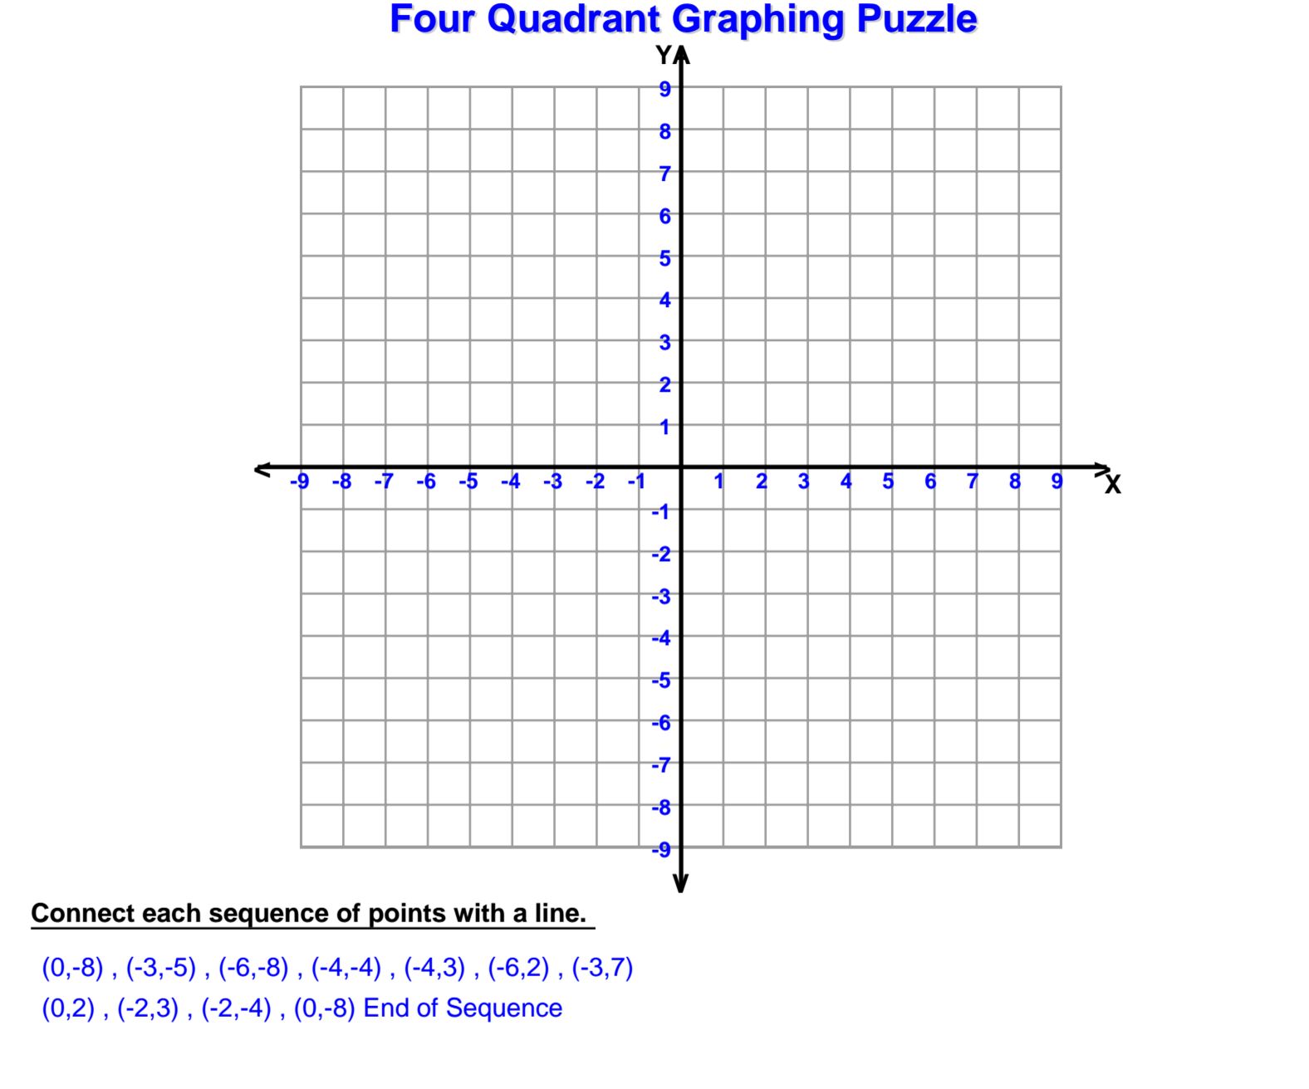

What is the shape?__________________________________